Project : AI-Based Final Year Project Assistant (FYP Smart Guide)


Submitted By:
Student Name | Roll No
Saad Ullah Rashid | SU92-BSCSM-F23-321
M Zaman Sial | SU92-BSCSM-F23-081
Muhammad Hussnain Ashiq | SU92-BSCSM-F23-347
Umar Zaman | SU92-BSCSM-F23-496
Muhammad Ahmad | SU92-BSCSM-F23-682
Muhammad Gohar | SU92-BSCSM-F23-147

Submitted To: Sir Talha

Department Of Computer Science

AI-Based Final Year Project Assistant (FYP Smart Guide)

1. Introduction :
FYP Smart Guide is an AI-powered web application designed to assist final-year university students in Pakistan. Many students face difficulties in selecting project ideas, writing structured documentation, formatting reports, and preparing for viva presentations.
This platform provides complete guidance from idea selection to final presentation, ensuring academic quality, reduced stress, and improved confidence.

2. Idea Evaluation Framework :
To finalize this idea, we evaluated it based on three major criteria:

2.1 Alignment with Skill Set
• The project aligns with our skills in frontend development (HTML, CSS, Bootstrap, JavaScript).
• Backend development expertise using Django and Django REST Framework.
• Database management using PostgreSQL.
• Basic AI and NLP integration knowledge.
The idea is technically feasible within our capabilities and academic timeframe.

2.2 Technique Used in the Idea
The following innovation techniques were applied:
• Design Thinking – Understanding student pain points.
• Observing Trends – Increasing use of AI in education.
• SCAMPER Method – Improving traditional project idea platforms.
• Five Discovery Skills – Associating AI with academic workflow.
These techniques ensure the solution is realistic, scalable, and adaptable.

2.3 Market Need, Want, and Demand Need
Students struggle with idea selection, documentation formatting, and viva preparation.
Want
Students want quick solutions, structured templates, and confidence-building tools.
Demand
Thousands of BSCS, IT, and Software Engineering students complete FYP every year in Pakistan. Students are willing to pay for affordable academic assistance.

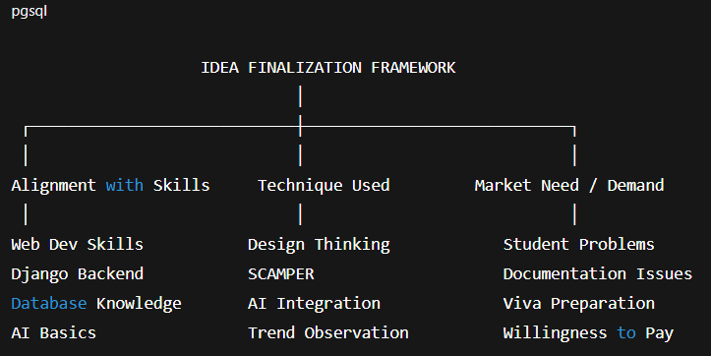

3. Problem Statement
Final-year students lack a centralized, structured, and affordable system that helps them generate ideas, prepare documentation, format reports, and prepare for viva.
This leads to:
• Confusion in selecting innovative and feasible project topics.
• High dependency on freelancers or pre-made projects.
• Increased plagiarism due to copying from online sources.
• Poor-quality documentation that does not meet university standards.
In addition:
• Many students are unaware of proper report structure and formatting guidelines.
• There is limited access to personalized academic guidance outside classroom supervision.
• Students struggle with time management while balancing coursework and project work.
• Lack of confidence during viva due to insufficient preparation and understanding of their own project.

As a result, students often experience stress, low academic performance, and reduced project quality, highlighting the urgent need for an intelligent, structured academic support system.
4. Proposed Solution
FYP Smart Guide will provide a comprehensive AI-powered academic assistance platform designed specifically for final-year university students. The system will offer intelligent, structured, and step-by-step support throughout the entire FYP journey.
Key Features:
• AI-Based Project Idea Generator
Generates innovative, feasible, and domain-specific project ideas based on student interests, technologies, and industry trends.
• Smart Documentation Templates
Provides structured templates for proposal, SRS, synopsis, final report, and presentation slides according to university standards.
• Automated Report Formatting Assistant
Assists students in formatting their reports (font style, headings, citations, references, margins, table of contents) according to academic guidelines.
• AI-Powered Viva Question Generator
Generates expected viva questions based on the student’s project title and domain, helping improve preparation and confidence.
• Step-by-Step Project Roadmap Guidance
Offers a structured timeline from idea approval to final submission, including milestones, weekly goals, and progress tracking.
• Plagiarism Reduction Support
Encourages originality by generating structured and customized content instead of copied material.
• Personalized Recommendations
Suggests technologies, tools, datasets, and implementation strategies according to project type.
• Progress Tracking Dashboard
Allows students to monitor their project stages and completion percentage.

5. System Architecture

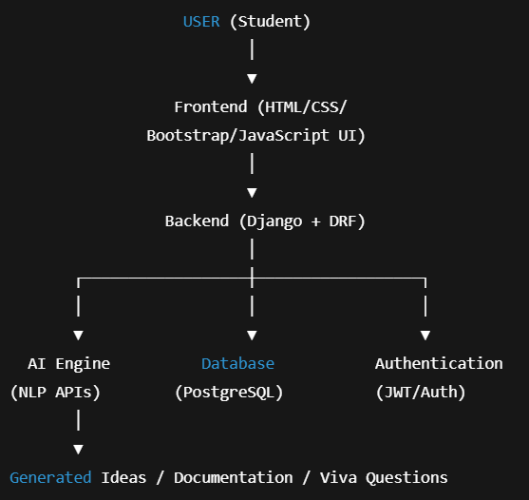

6. Technology Stack
Frontend
• HTML
• CSS
• Bootstrap
• JavaScript
Backend
• Django
• Django REST Framework
Database
• PostgreSQL
Tools
• VS Code
• GitHub
• Cloud Hosting (AWS / Render)
AI Integration
• NLP-based text generation
• Prompt engineering
• Structured content automation

7. Business Model
Freemium Model
Free Version
• Limited project ideas
• Basic templates
• Limited viva questions
Premium Version
• Full documentation support
• Advanced formatting
• Personalized project roadmap
• Complete viva preparation
Target users: BSCS, IT, and Software Engineering students.

8. Feasibility Analysis
Technical Feasibility
Achievable using existing web and AI technologies.
Economic Feasibility
Low development cost with high potential demand.
Operational Feasibility
Easy deployment as a web-based cloud application.

9. Advantages
• Saves time
• Reduces stress
• Improves academic quality
• Encourages originality
• Scalable startup potential

10. Limitations
• AI output may require editing
• Not a replacement for academic supervisor
• Initial version may support limited domains

11. Future Scope
• Built-in plagiarism checker
• ER diagram generator
• UML diagram auto-creator
• Supervisor dashboard
• Expansion to international universities

12. Conclusion
AI-Based Final Year Project Assistant (FYP Smart Guide) is a practical and scalable academic solution that integrates AI with structured academic guidance.
The project is technically feasible, market-relevant, innovative, and aligned with our skill set. It has strong potential to evolve into a successful EdTech startup.

